Spring 3 MVC hello world example
By mkyong | August 2, 2011 | Updated : June 15, 2015 | Viewed : 791,981 times +1,736 pv/w
In this tutorial, we show you a Spring 3 MVC hello world example, using Maven build tool.
Technologies used :
- Spring 3.2.13.RELEASE
- Maven 3
- JDK 1.6
- Eclipse 4.4
- Boostrap 3
Spring 4 MVC XML
Try this Spring 4 MVC hello world example.
Spring 3 MVC Annotation
Try this Spring 3 MVC hello world annotation example.

1. Project Structure
Download the project source code and review the project folder structure :
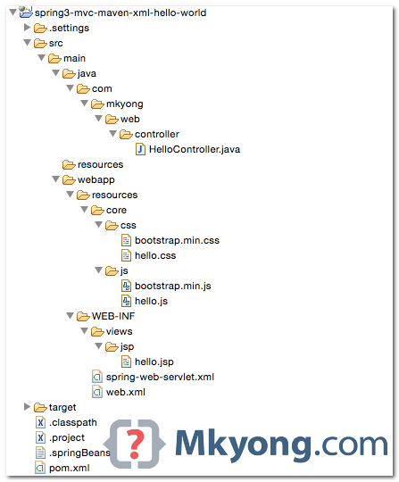

2. Maven
A pom.xml template to quick start a Spring MVC project, it defines Spring 3 dependencies, an embedded Jetty container and Eclipse workspace configuration.
pom.xml
<project xmlns="http://maven.apache.org/POM/4.0.0"
xmlns:xsi="http://www.w3.org/2001/XMLSchema-instance"
xsi:schemaLocation="http://maven.apache.org/POM/4.0.0
http://maven.apache.org/maven-v4_0_0.xsd">
<modelVersion>4.0.0</modelVersion>
<groupId>com.mkyong</groupId>
<artifactId>spring3-web</artifactId>
<packaging>war</packaging>
<version>1.0-SNAPSHOT</version>
<name>spring css</name>

<properties>
<jdk.version>1.6</jdk.version>
<spring.version>3.2.13.RELEASE</spring.version>
<jstl.version>1.2</jstl.version>
</properties>

<dependencies>
<dependency>
<groupId>org.springframework</groupId>
<artifactId>spring-webmvc</artifactId>
<version>${spring.version}</version>
</dependency>
<dependency>
<groupId>javax.servlet</groupId>
<artifactId>jstl</artifactId>
<version>${jstl.version}</version>
</dependency>
</dependencies>

<build>
<plugins>
<plugin>
<groupId>org.apache.maven.plugins</groupId>
<artifactId>maven-compiler-plugin</artifactId>
<version>3.3</version>
<configuration>
<source>${jdk.version}</source>
<target>${jdk.version}</target>
</configuration>
</plugin>

<!-- embedded Jetty server, for testing -->
<plugin>
<groupId>org.eclipse.jetty</groupId>
<artifactId>jetty-maven-plugin</artifactId>
<version>9.2.11.v20150529</version>
<configuration>
<scanIntervalSeconds>10</scanIntervalSeconds>
<webApp>
<contextPath>/spring3</contextPath>
</webApp>
</configuration>
</plugin>

<!-- configure Eclipse workspace -->
<plugin>
<groupId>org.apache.maven.plugins</groupId>
<artifactId>maven-eclipse-plugin</artifactId>
<version>2.9</version>
<configuration>
<downloadSources>true</downloadSources>
<downloadJavadocs>true</downloadJavadocs>
<wtpversion>2.0</wtpversion>
<wtpContextName>spring3</wtpContextName>
</configuration>
</plugin>
</plugins>
</build>

</project>

3. Controller & Mapping
The @RequestMapping has been available since 2.5, but now enhanced to support REST style URLs.
HelloController.java
package com.mkyong.web.controller;

import org.springframework.stereotype.Controller;
import org.springframework.ui.ModelMap;
import org.springframework.web.bind.annotation.PathVariable;
import org.springframework.web.bind.annotation.RequestMapping;
import org.springframework.web.bind.annotation.RequestMethod;
import org.springframework.web.servlet.ModelAndView;

@Controller
public class HelloController {

@RequestMapping(value = "/", method = RequestMethod.GET)
public String printWelcome(ModelMap model) {

model.addAttribute("message", "Spring 3 MVC Hello World");
return "hello";

}

@RequestMapping(value = "/hello/{name:.+}", method = RequestMethod.GET)
public ModelAndView hello(@PathVariable("name") String name) {

ModelAndView model = new ModelAndView();
model.setViewName("hello");
model.addObject("msg", name);

return model;

}

}

4. JSP Views
A JSP page to display the value, and include bootstrap css and js.
html4strict
<%@ taglib prefix="spring" uri="http://www.springframework.org/tags"%>
<%@ taglib prefix="c" uri="http://java.sun.com/jsp/jstl/core"%>
<!DOCTYPE html>
<html lang="en">
<head>
<title>Maven + Spring MVC</title>

<spring:url value="/resources/core/css/hello.css" var="coreCss" />
<spring:url value="/resources/core/css/bootstrap.min.css" var="bootstrapCss" />
<link href="${bootstrapCss}" rel="stylesheet" />
<link href="${coreCss}" rel="stylesheet" />
</head>

<nav class="navbar navbar-inverse navbar-fixed-top">
<div class="container">
<div class="navbar-header">
<a class="navbar-brand" href="#">Spring 3 MVC Project</a>
</div>
</div>
</nav>

<div class="jumbotron">
<div class="container">
<h1>${title}</h1>
<p>
<c:if test="${not empty name}">
Hello ${name}
</c:if>

<c:if test="${empty name}">
Welcome Welcome!
</c:if>
</p>
<p>
<a class="btn btn-primary btn-lg" href="#" role="button">Learn more</a>
</p>
</div>
</div>

<div class="container">

<div class="row">
<div class="col-md-4">
<h2>Heading</h2>
<p>ABC</p>
<p>
<a class="btn btn-default" href="#" role="button">View details</a>
</p>
</div>
<div class="col-md-4">
<h2>Heading</h2>
<p>ABC</p>
<p>
<a class="btn btn-default" href="#" role="button">View details</a>
</p>
</div>
<div class="col-md-4">
<h2>Heading</h2>
<p>ABC</p>
<p>
<a class="btn btn-default" href="#" role="button">View details</a>
</p>
</div>
</div>

<hr>
<footer>
<p>© Mkyong.com 2015</p>
</footer>
</div>

<spring:url value="/resources/core/css/hello.js" var="coreJs" />
<spring:url value="/resources/core/css/bootstrap.min.js" var="bootstrapJs" />

<script src="${coreJs}"></script>
<script src="${bootstrapJs}"></script>
<script src="https://ajax.googleapis.com/ajax/libs/jquery/1.11.2/jquery.min.js"></script>

</body>
</html>

5. Spring XML Configuration
5.1 Enable component scanning, view resolver and resource mapping.
spring-web-servlet.xml
<beans xmlns="http://www.springframework.org/schema/beans"
xmlns:context="http://www.springframework.org/schema/context"
xmlns:xsi="http://www.w3.org/2001/XMLSchema-instance"
xmlns:mvc="http://www.springframework.org/schema/mvc"
xsi:schemaLocation="
http://www.springframework.org/schema/beans
http://www.springframework.org/schema/beans/spring-beans-3.2.xsd
http://www.springframework.org/schema/mvc
http://www.springframework.org/schema/mvc/spring-mvc-3.2.xsd
http://www.springframework.org/schema/context
http://www.springframework.org/schema/context/spring-context-3.2.xsd">

<context:component-scan base-package="com.mkyong.web" />

<bean
class="org.springframework.web.servlet.view.InternalResourceViewResolver">
<property name="prefix">
<value>/WEB-INF/views/jsp/</value>
</property>
<property name="suffix">
<value>.jsp</value>
</property>
</bean>

<mvc:resources mapping="/resources/**" location="/resources/" />

<mvc:annotation-driven />

</beans>
5.2 Declares a DispatcherServlet in web.xml. If the Spring XML configuration file is NOT specified, Spring will look for the {servlet-name}-servlet.xml.
In this example, Spring will look for the spring-web-servlet.xml file.
web.xml
<web-app xmlns="http://java.sun.com/xml/ns/javaee"
xmlns:xsi="http://www.w3.org/2001/XMLSchema-instance"
xsi:schemaLocation="http://java.sun.com/xml/ns/javaee
http://java.sun.com/xml/ns/javaee/web-app_2_5.xsd"
version="2.5">

<display-name>Spring3 MVC Application</display-name>

<servlet>
<servlet-name>spring-web</servlet-name>
<servlet-class>
org.springframework.web.servlet.DispatcherServlet
</servlet-class>
<load-on-startup>1</load-on-startup>
</servlet>

<servlet-mapping>
<servlet-name>spring-web</servlet-name>
<url-pattern>/</url-pattern>
</servlet-mapping>

</web-app>
You can define a Spring XML file via contextConfigLocation.
web.xml
<servlet>
<servlet-name>spring-web</servlet-name>
<servlet-class>
org.springframework.web.servlet.DispatcherServlet
</servlet-class>
<load-on-startup>1</load-on-startup>
<init-param>
<param-name>contextConfigLocation</param-name>
<param-value>/WEB-INF/spring-mvc-config.xml</param-value>
</init-param>
</servlet>

<servlet-mapping>
<servlet-name>spring-web</servlet-name>
<url-pattern>/</url-pattern>
</servlet-mapping>

6. Demo
The pom.xml file defines an embedded Jetty container. Issues mvn jetty:run to start the project.
Terminal
$ mvn jetty:run
...
[INFO] Started Jetty Server
[INFO] Starting scanner at interval of 10 seconds.
URL : http://localhost:8080/spring3
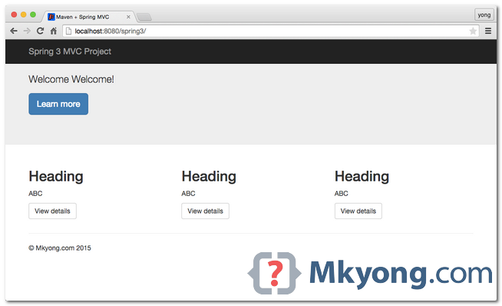
URL : http://localhost:8080/spring3/hello/mkyong
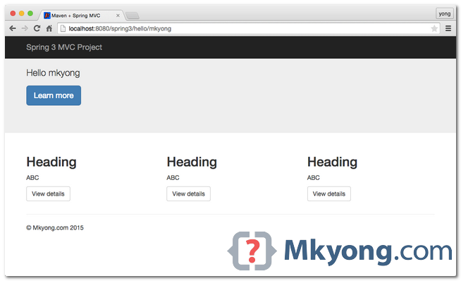

7. WAR File
To create a WAR file for deployment :
Terminal
your-project$ mvn war:war
A WAR file will be created in project\target\ folder.
${Project}\target\spring3-web-1.0-SNAPSHOT.war

Download Source Code
Download it – spring3-mvc-maven-xml-hello-world.zip (51 KB)
Github link – spring3-mvc-maven-xml-hello-world.git

References
- What new in Spring 3
- Spring 3 MVC and JSR303 @Valid example
- Spring 3 MVC and RSS feed example
- Spring 3 MVC and XML example
- Spring 3 MVC and JSON example
Tags : hello world spring mvc spring3

Spring 3 MVC hello world example – Annotation
By mkyong | June 3, 2015 | Updated : June 15, 2015 | Viewed : 122,499 times +922 pv/w
In this tutorial, we will take the previous Maven + Spring MVC XML example, rewrite it to support @JavaConfigconfiguration, no more XML files, and deploy it into a Servlet 3.0+ container, like Tomcat 7 or Jetty 9.
Technologies used :
- Spring 3.2.13.RELEASE
- Maven 3
- JDK 1.6
- Tomcat 7 or Jetty 9
- Eclipse 4.4
- Boostrap 3
Spring 4 MVC Annotation
Try this Spring 4 MVC hello world example – Annotation.

1. Project Structure
Download the project source code and review the project folder structure :
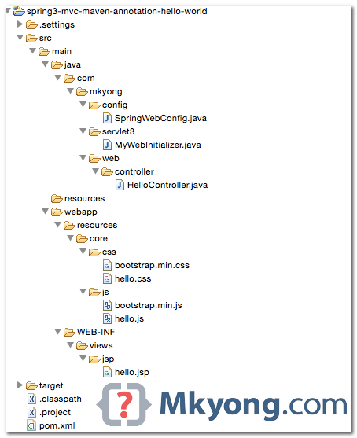
P.S No more XML files like web.xml or any other Spring XML configuration files.

2. Maven
2.1 A pom.xml template to quick start a Spring MVC project. To compile this project, we need to add a servlet-apidependency.
pom.xml
<project xmlns="http://maven.apache.org/POM/4.0.0"
xmlns:xsi="http://www.w3.org/2001/XMLSchema-instance"
xsi:schemaLocation="http://maven.apache.org/POM/4.0.0
http://maven.apache.org/maven-v4_0_0.xsd">
<modelVersion>4.0.0</modelVersion>
<groupId>com.mkyong</groupId>
<artifactId>spring3-mvc-maven-annotation-hello-world</artifactId>
<packaging>war</packaging>
<version>1.0-SNAPSHOT</version>
<name>spring mvc</name>

<properties>
<jdk.version>1.6</jdk.version>
<spring.version>3.2.13.RELEASE</spring.version>
<jstl.version>1.2</jstl.version>
<servletapi.version>3.1.0</servletapi.version>
</properties>

<dependencies>

<dependency>
<groupId>org.springframework</groupId>
<artifactId>spring-webmvc</artifactId>
<version>${spring.version}</version>
</dependency>

<dependency>
<groupId>javax.servlet</groupId>
<artifactId>jstl</artifactId>
<version>${jstl.version}</version>
</dependency>

<!-- compile only, deployed container will provide this -->
<dependency>
<groupId>javax.servlet</groupId>
<artifactId>javax.servlet-api</artifactId>
<version>${servletapi.version}</version>
<scope>provided</scope>
</dependency>

</dependencies>

<build>
<plugins>

<plugin>
<groupId>org.apache.maven.plugins</groupId>
<artifactId>maven-compiler-plugin</artifactId>
<version>3.3</version>
<configuration>
<source>${jdk.version}</source>
<target>${jdk.version}</target>
</configuration>
</plugin>

<!-- embedded Jetty server, for testing -->
<plugin>
<groupId>org.eclipse.jetty</groupId>
<artifactId>jetty-maven-plugin</artifactId>
<version>9.2.11.v20150529</version>
<configuration>
<scanIntervalSeconds>10</scanIntervalSeconds>
<webApp>
<contextPath>/spring3</contextPath>
</webApp>
</configuration>
</plugin>

<!-- configure Eclipse workspace -->
<plugin>
<groupId>org.apache.maven.plugins</groupId>
<artifactId>maven-eclipse-plugin</artifactId>
<version>2.9</version>
<configuration>
<downloadSources>true</downloadSources>
<downloadJavadocs>true</downloadJavadocs>
<wtpversion>2.0</wtpversion>
<wtpContextName>spring3</wtpContextName>
</configuration>
</plugin>

</plugins>
</build>

</project>
2.2 To compile this project and make it supports Eclipse IDE.
Terminal
$ mvn eclipse:eclipse

3. Spring Controller
HelloController.java
package com.mkyong.web.controller;

import org.springframework.stereotype.Controller;
import org.springframework.ui.ModelMap;
import org.springframework.web.bind.annotation.PathVariable;
import org.springframework.web.bind.annotation.RequestMapping;
import org.springframework.web.bind.annotation.RequestMethod;
import org.springframework.web.servlet.ModelAndView;

@Controller
public class HelloController {

@RequestMapping(value = "/", method = RequestMethod.GET)
public String printWelcome(ModelMap model) {

model.addAttribute("message", "Spring 3 MVC Hello World");
return "hello";

}

@RequestMapping(value = "/hello/{name:.+}", method = RequestMethod.GET)
public ModelAndView hello(@PathVariable("name") String name) {

ModelAndView model = new ModelAndView();
model.setViewName("hello");
model.addObject("msg", name);

return model;

}

}

4. JSP Views
A JSP page to display the value, and include bootstrap css and js.
html4strict
<%@ taglib prefix="spring" uri="http://www.springframework.org/tags"%>
<%@ taglib prefix="c" uri="http://java.sun.com/jsp/jstl/core"%>
<!DOCTYPE html>
<html lang="en">
<head>
<title>Maven + Spring MVC + @JavaConfig</title>

<spring:url value="/resources/core/css/hello.css" var="coreCss" />
<spring:url value="/resources/core/css/bootstrap.min.css" var="bootstrapCss" />
<link href="${bootstrapCss}" rel="stylesheet" />
<link href="${coreCss}" rel="stylesheet" />
</head>

<nav class="navbar navbar-inverse navbar-fixed-top">
<div class="container">
<div class="navbar-header">
<a class="navbar-brand" href="#">Spring 3 MVC Project @JavaConfig</a>
</div>
</div>
</nav>

<div class="jumbotron">
<div class="container">
<h1>${title}</h1>
<p>
<c:if test="${not empty name}">
Hello ${name}
</c:if>

<c:if test="${empty name}">
Welcome Welcome!
</c:if>
</p>
<p>
<a class="btn btn-primary btn-lg" href="#" role="button">Learn more</a>
</p>
</div>
</div>

<div class="container">

<div class="row">
<div class="col-md-4">
<h2>Heading</h2>
<p>ABC</p>
<p>
<a class="btn btn-default" href="#" role="button">View details</a>
</p>
</div>
<div class="col-md-4">
<h2>Heading</h2>
<p>ABC</p>
<p>
<a class="btn btn-default" href="#" role="button">View details</a>
</p>
</div>
<div class="col-md-4">
<h2>Heading</h2>
<p>ABC</p>
<p>
<a class="btn btn-default" href="#" role="button">View details</a>
</p>
</div>
</div>

<hr>
<footer>
<p>© Mkyong.com 2015</p>
</footer>
</div>

<spring:url value="/resources/core/css/hello.js" var="coreJs" />
<spring:url value="/resources/core/css/bootstrap.min.js" var="bootstrapJs" />

<script src="${coreJs}"></script>
<script src="${bootstrapJs}"></script>
<script src="https://ajax.googleapis.com/ajax/libs/jquery/1.11.2/jquery.min.js"></script>

</body>
</html>

5. Spring @JavaConfig
SpringWebConfig.java
package com.mkyong.config;

import org.springframework.context.annotation.Bean;
import org.springframework.context.annotation.ComponentScan;
import org.springframework.context.annotation.Configuration;
import org.springframework.web.servlet.config.annotation.EnableWebMvc;
import org.springframework.web.servlet.config.annotation.ResourceHandlerRegistry;
import org.springframework.web.servlet.config.annotation.WebMvcConfigurerAdapter;
import org.springframework.web.servlet.view.InternalResourceViewResolver;
import org.springframework.web.servlet.view.JstlView;

@EnableWebMvc //mvc:annotation-driven
@Configuration
@ComponentScan({ "com.mkyong.web" })
public class SpringWebConfig extends WebMvcConfigurerAdapter {

@Override
public void addResourceHandlers(ResourceHandlerRegistry registry) {
registry.addResourceHandler("/resources/**").addResourceLocations("/resources/");
}

@Bean
public InternalResourceViewResolver viewResolver() {
InternalResourceViewResolver viewResolver = new InternalResourceViewResolver();
viewResolver.setViewClass(JstlView.class);
viewResolver.setPrefix("/WEB-INF/views/jsp/");
viewResolver.setSuffix(".jsp");
return viewResolver;
}

}
XML equivalent.
<beans xmlns="http://www.springframework.org/schema/beans"
xmlns:context="http://www.springframework.org/schema/context"
xmlns:xsi="http://www.w3.org/2001/XMLSchema-instance"
xmlns:mvc="http://www.springframework.org/schema/mvc"
xsi:schemaLocation="
http://www.springframework.org/schema/beans
http://www.springframework.org/schema/beans/spring-beans-3.2.xsd
http://www.springframework.org/schema/mvc
http://www.springframework.org/schema/mvc/spring-mvc-3.2.xsd
http://www.springframework.org/schema/context
http://www.springframework.org/schema/context/spring-context-3.2.xsd">

<context:component-scan base-package="com.mkyong.web" />

<bean
class="org.springframework.web.servlet.view.InternalResourceViewResolver">
<property name="prefix">
<value>/WEB-INF/views/jsp/</value>
</property>
<property name="suffix">
<value>.jsp</value>
</property>
</bean>

<mvc:resources mapping="/resources/**" location="/resources/" />

<mvc:annotation-driven />

</beans>

6. Servlet 3.0+ Container
Create a ServletInitializer class by extending AbstractAnnotationConfigDispatcherServletInitializer, the Servlet 3.0+ container will pick up this class and run it automatically. This is the replacement for web.xml.
MyWebInitializer.java
package com.mkyong.servlet3;

import org.springframework.web.servlet.support.AbstractAnnotationConfigDispatcherServletInitializer;

import com.mkyong.config.SpringWebConfig;

public class MyWebInitializer extends
AbstractAnnotationConfigDispatcherServletInitializer {

@Override
protected Class<?>[] getServletConfigClasses() {
return new Class[] { SpringWebConfig.class };
}

@Override
protected String[] getServletMappings() {
return new String[] { "/" };
}

@Override
protected Class<?>[] getRootConfigClasses() {
return null;
}

}

7. Demo
Download the project and run it with the embedded Jetty container.
Terminal
$ mvn jetty:run
URL : http://localhost:8080/spring3

URL : http://localhost:8080/spring3/hello/mkyong


Download Source Code
Download it – spring3-mvc-maven-annotation-hello-world (47 KB)
Github link – spring3-mvc-maven-annotation-hello-world.git

References
- What new in Spring 3
- Spring 3 MVC and XML example
- Spring 3 MVC and JSON example
Tags : maven spring config spring mvc spring3

